**Assignment No:-56**

Name:-Suryawanshi Sangramsingh Sambhaji

Batch: - Delta - DCA (Java) 2024 Date:-31/7/2024

**CREATE DATABASE ORG; SHOW DATABASES;**

**USE ORG;**

**create table worker (worker_id int not null primary key auto_increment, first_name char(25),last_name char(25), salary int(15),joining_date datetime, department char(25));**

**INSERT INTO worker (worker_id, first_name, last_name, salary, joining_date, department)**

**VALUES**

**(001, 'monika', 'arora', 100000, '14-02-20 09.00.00', 'hr'),**

**(002, 'niharika', 'verma', 80000, '14-06-11 09.00.00', 'admin'),**

**(003, 'vishal', 'singhal', 300000, '14-02-20 09.00.00', 'hr'),**

**(004, 'amitabh', 'singh', 500000, '14-02-20 09.00.00', 'admin'),**

**(005, 'vivek', 'bhati', 500000, '14-06-11 09.00.00', 'admin'),**

**(006, 'vipul', 'diwan', 200000, '14-06-11 09.00.00', 'account'),**

**(007, 'satish', 'kumar', 75000, '14-01-20 09.00.00', 'account'),**

**(008, 'geetika', 'chauhan', 90000, '14-04-11 09.00.00', 'admin');**

**create table bonus (worker_ref_id int,bonus_amount int(10), bonus_date datetime,foreign key (worker_ref_id)references worker(worker_id) on delete cascade);**

**INSERT INTO bonus (worker_ref_id, bonus_amount, bonus_date)**

**VALUES**

**(001, 5000, '16-02-20'),**

**(002, 3000, '16-06-11'),**

**(003, 4000, '16-02-20'),**

**(001, 4500, '16-02-20'),**

**(002, 3500, '16-06-11');**

**create table title (**

**worker_ref_id int,**

**worker_title char(25),**

**affected_from datetime,**

**foreign key (worker_ref_id) references worker(worker_id) on delete cascade**

**);**

**insert into title (worker_ref_id, worker_title, affected_from)**

**values**

**(001, 'manager', '2016-02-20 00:00:00'),**

**(002, 'executive', '2016-06-11 00:00:00'),**

**(008, 'executive', '2016-06-11 00:00:00'),**

**(005, 'manager', '2016-06-11 00:00:00'),**

**(004, 'asst. manager', '2016-06-11 00:00:00'),**

**(007, 'executive', '2016-06-11 00:00:00'),**

**(006, 'lead', '2016-06-11 00:00:00'),**

**(003, 'lead', '2016-06-11 00:00:00');**

|  |  |  |
| --- | --- | --- |
|  |  |  |

Sample Table – Worker

|  |  |  |  |  |  |
| --- | --- | --- | --- | --- | --- |
| **WORKER_ID** | **FIRST_NAME** | **LAST_NAME** | **SALARY** | **JOINING_DATE** | **DEPARTMENT** |
| **001** | **Monika** | **Arora** | **100000** | **2014-02-20 09:00:00** | **HR** |
| **002** | **Niharika** | **Verma** | **80000** | **2014-06-11 09:00:00** | **Admin** |
| **003** | **Vishal** | **Singhal** | **300000** | **2014-02-20 09:00:00** | **HR** |
| **004** | **Amitabh** | **Singh** | **500000** | **2014-02-20 09:00:00** | **Admin** |
| **005** | **Vivek** | **Bhati** | **500000** | **2014-06-11 09:00:00** | **Admin** |
| **006** | **Vipul** | **Diwan** | **200000** | **2014-06-11 09:00:00** | **Account** |
| **007** | **Satish** | **Kumar** | **75000** | **2014-01-20 09:00:00** | **Account** |
| **008** | **Geetika** | **Chauhan** | **90000** | **2014-04-11 09:00:00** | **Admin** |

Sample Table – Bonus

|  |  |  |  |
| --- | --- | --- | --- |
| **WORKER_REF_ID** | **BONUS_DATE** | **BONUS_AMOUNT** |  |
| **1** | **2016-02-20 00:00:00** | **5000** |
| **2** | **2016-06-11 00:00:00** | **3000** |
| **3** | **2016-02-20 00:00:00** | **4000** |
| **1** | **2016-02-20 00:00:00** | **4500** |
| **2** | **2016-06-11 00:00:00** | **3500** |
| **Sample Table – Title** | | |
| **WORKER_REF_ID** | **WORKER_TITLE** | **AFFECTED_FROM** | |
| **1** | **Manager** | **2016-02-20 00:00:00** | |
| **2** | **Executive** | **2016-06-11 00:00:00** | |
| **8** | **Executive** | **2016-06-11 00:00:00** | |
| **5** | **Manager** | **2016-06-11 00:00:00** | |
| **4** | **Asst. Manager** | **2016-06-11 00:00:00** | |
| **7** | **Executive** | **2016-06-11 00:00:00** | |
| **6** | **Lead** | **2016-06-11 00:00:00** | |
| **3** | **Lead** | **2016-06-11 00:00:00** | |

Q-1. Write an SQL query to fetch “FIRST_NAME” from Worker table using the alias name as <WORKER_NAME>.

select first_name As Worker_Name from worker;

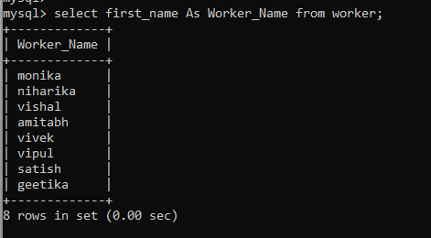

Q-2. Write an SQL query to fetch “FIRST_NAME” from Worker table in upper case.

select upper(first_name) As Worker_Name from worker;

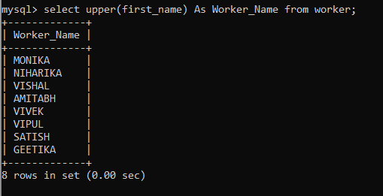

Q-3. Write an SQL query to fetch unique values of DEPARTMENT from Worker table.

select distinct department from Worker;

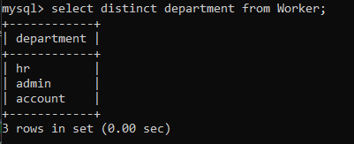

Q-6 Write an SQL query to print the FIRST_NAME from Worker table after removing white spaces from the right side.

select rtrim(first_name) As Worker_Name from worker;

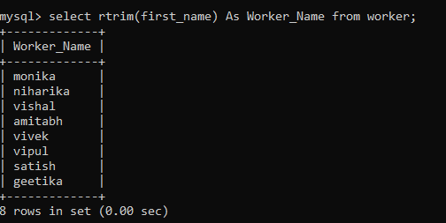

Q-7. Write an SQL query to print the DEPARTMENT from Worker table after removing white spaces from the left side.

select ltrim(department) As Department_Worker from worker;

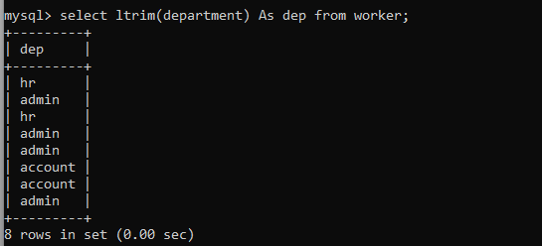

Q-8. Write an SQL query that fetches the unique values of DEPARTMENT from Worker table and prints its length.

select count(department) As Department_Length from worker group by department;

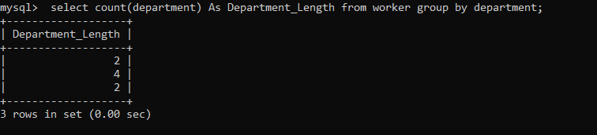

Q-9 Write an SQL query to print details of Workers with DEPARTMENT name as “Admin”.

select * from worker where department='Admin';

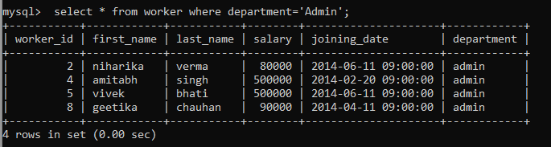

Q-10. Write an SQL query to print details of the Workers whose FIRST_NAME contains ‘a’.

select * from worker where first_name like 'a%';

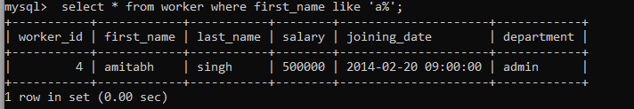

Q-11. Write an SQL query to print details of the Workers whose FIRST_NAME ends with ‘a’.

select * from worker where first_name like '%a';

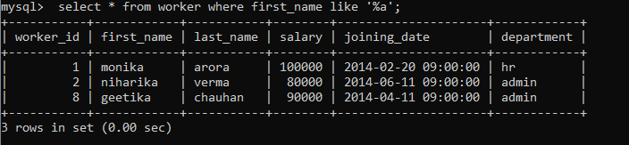

Q-12. Write an SQL query to print details of the Workers whose FIRST_NAME ends with ‘h’.

select * from worker where first_name like '%h';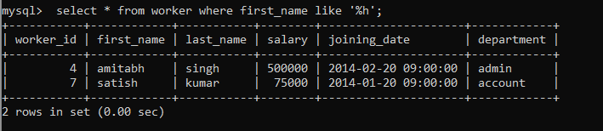

Q-13. Write an SQL query to print details of the Workers whose SALARY lies between 100000 and 500000.

select * from worker where salary>100000 and salary<500000;

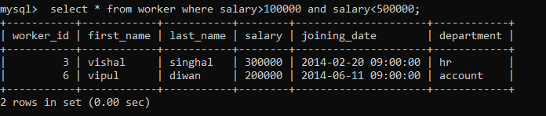

Q-14. Write an SQL query to print details of the Workers who have joined in Feb’2014.

select * from worker where joining_date>='2014-02-01' and joining_date<'2014-03-1';

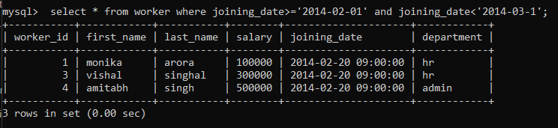

Q-15. Write an SQL query to fetch the count of employees working in the department ‘Admin’.

select count(department) As Admin_count from worker where department='Admin'group by department;

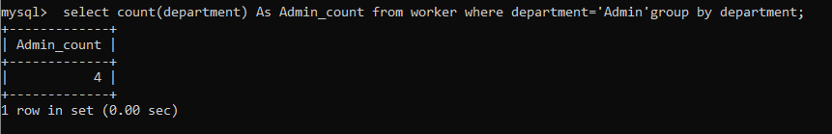

Q-16. Write an SQL query to fetch worker names with salaries >= 50000 and

<= 100000.

select first_name,last_name,salary from worker where salary>=50000 and salary<=100000;

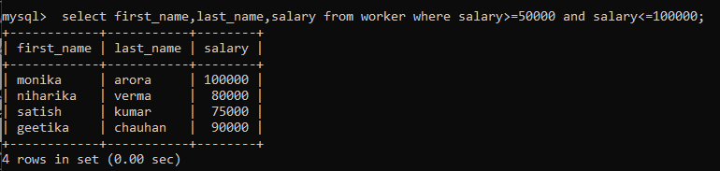

Q-17. Write an SQL query to fetch the no. of workers for each department in the descending order.

select * from worker order by department desc;

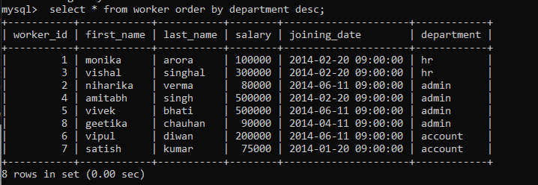

Q-18. Write an SQL query to print details of the Workers who are also Managers.

select Title.worker_ref_id,Worker.worker_id,first_name from worker inner join Title on Worker.worker_id=Title.worker_ref_id where Title.worker_title='Manager';

